**Matlab Training**

**LAB # 01**



**FALL 2021**

**CSE309L-Digital Signal Processing**

Submitted by: **Ashfaq Ahmad**

Registration No: **19PWCSE1795**

Class Section: **B**

“On my honor, as student of University of Engineering and Technology, I have neither given nor received unauthorized assistance on this academic work.”

Student Signature: ______________

Submitted to:

**Prof. Ihsan Ul Haq**

November 18, 2021

**Department of Computer Systems Engineering**

**University of Engineering and Technology, Peshawar**

**CSE 309L: Communication Systems**

|  |  |  |  |  |
| --- | --- | --- | --- | --- |
| **Demonstration of Concepts** | **Poor (Does not meet expectation (1))**  The student failed to demonstrate a clear understanding of the assignment concepts | **Fair (Meet Expectation (2-3))**  The student demonstrated a clear understanding of some of the assignment concepts | **Good (Exceeds Expectation (4-5)**  The student demonstrated a clear understanding of the assignment concepts | **Score**  **30%** |
| **Accuracy** | The student mis-configured enough signal processing settings that the computer couldn't function properly. | The student configured enough signal processing settings that the computer partially functioned | The student configured the signal processing settings that the computer fully functioned | **30%** |
| **Following Directions** | The student clearly failed to follow the verbal and written instructions to successfully complete the lab | The student failed to follow the some of the verbal and written instructions to successfully complete all requirements of the lab | The student followed the verbal and written instructions to successfully complete requirements of the lab | **20%** |
| **Time Utilization** | The student failed to complete even part of the lab in the allotted amount of time | The student failed to complete the entire lab in the allotted amount of time | The student completed the lab in its entirety in the allotted amount of time | **20%** |

1. **Course Overview**
   1. Objective: Familiarize yourself with the course.
   2. Remarks along with final snapshot

**Remarks:**

* **First of all we will learn how to do online courses.**
* **We will learn all basics commands of Matlab**
* **We will know about the Matlab script and graphs**
* **Finally we will get certificate.**

### Commands

### Objective: Enter commands in MATLAB to perform calculations and create variables.

* 1. Remarks along with final snapshot

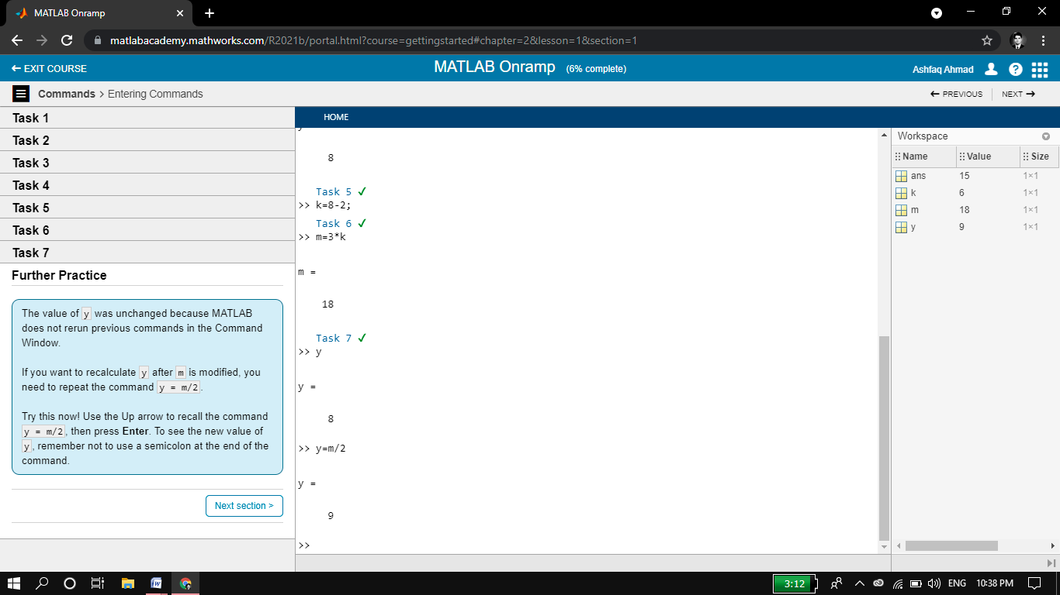

Remark:

* We can create variables in matlab software without specifying their data types. Once we create the variable it store in workspace of matlab.
* We can use such variable again if we need also we can edit their value.
* There are some special default variables pi,ans,eps, i and j.

### Vectors and Matrices

### Objective: Create MATLAB variables that contain multiple elements.

* 1. Remarks along with final snapshot.

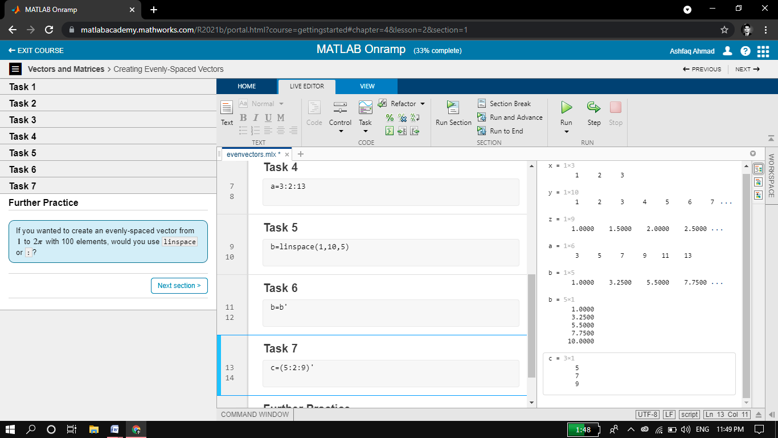

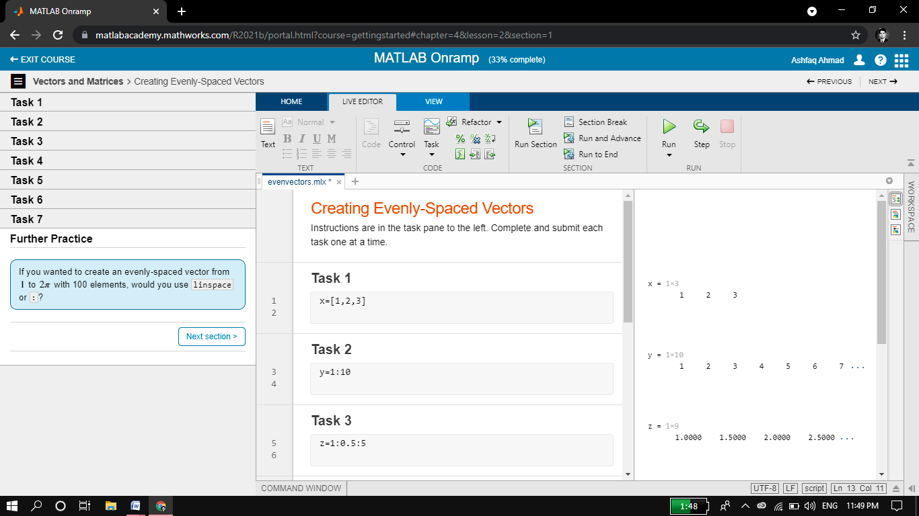

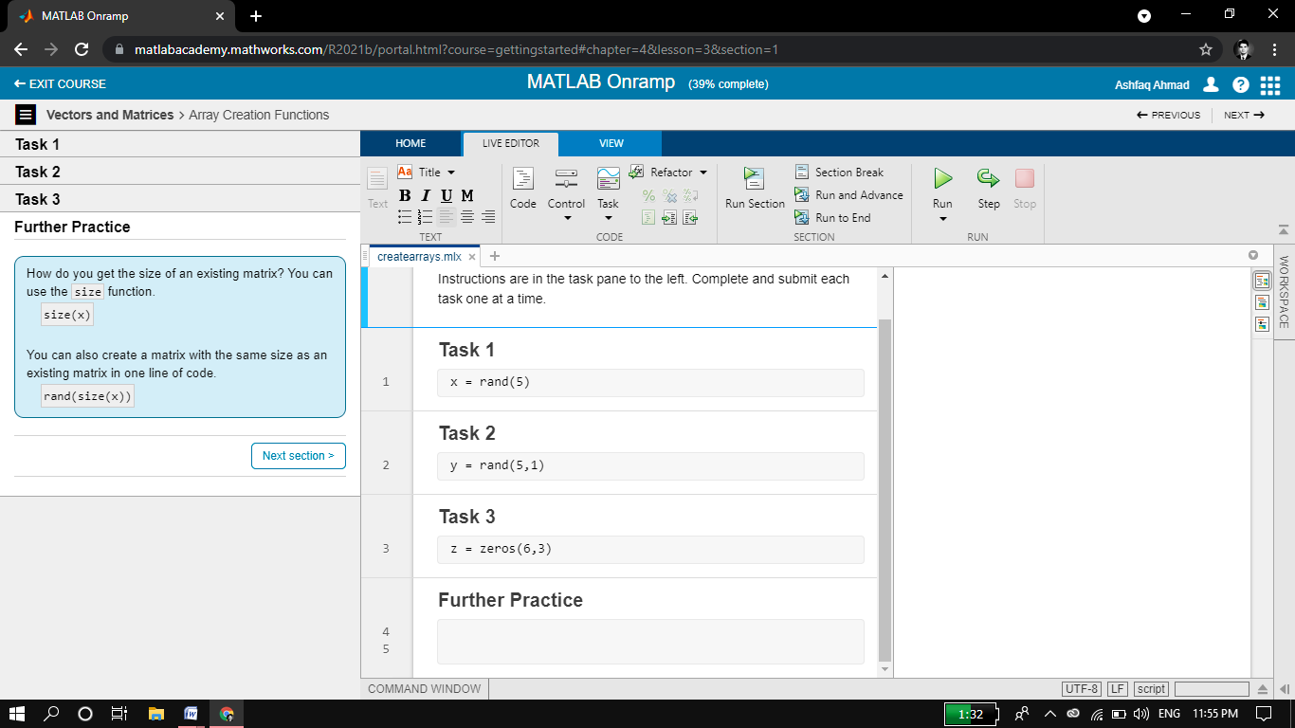

Remark:

* In matlab a single variable is also consider as vector of size 1x1. We can create a row matrix by entering elements in a square brackets separated by coma (,). While in case of column matrix the elements are separated by semi colon (;). We can create nxn matrix easily.
* By using linespace we can create a vector having upper boundary, lower boundary and size of vector.
* We can transpose a vector by using (‘) sign.
* We can find size of matrix using size command.

### Importing Data

### Objective: Bring data from external files into MATLAB.

* 1. Remarks along with final snapshot

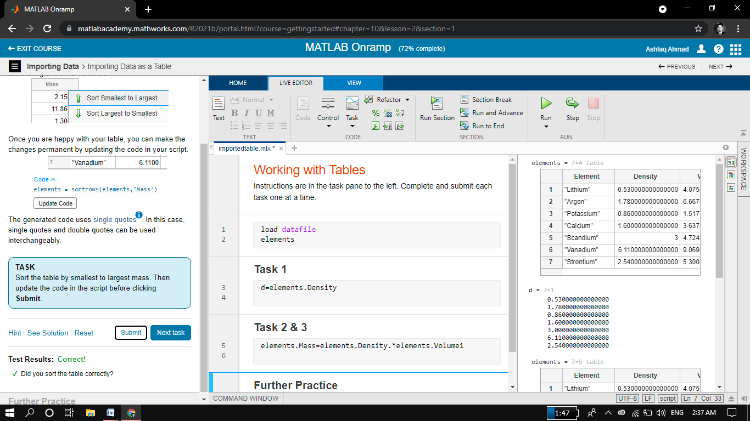

Remarks:

* Importing data in MATLAB means loading data from an external file. The **importdata** function allows loading various data files of different formats.
* **A = importdata(filename)**
* Loads data into array A from the file denoted by *filename*.
* We can sort data in table using dot (.) operator.

### Indexing into and Modifying Arrays

### Use indexing to extract and modify rows, columns, and elements of MATLAB arrays.

* 1. Remarks along with final snapshot.

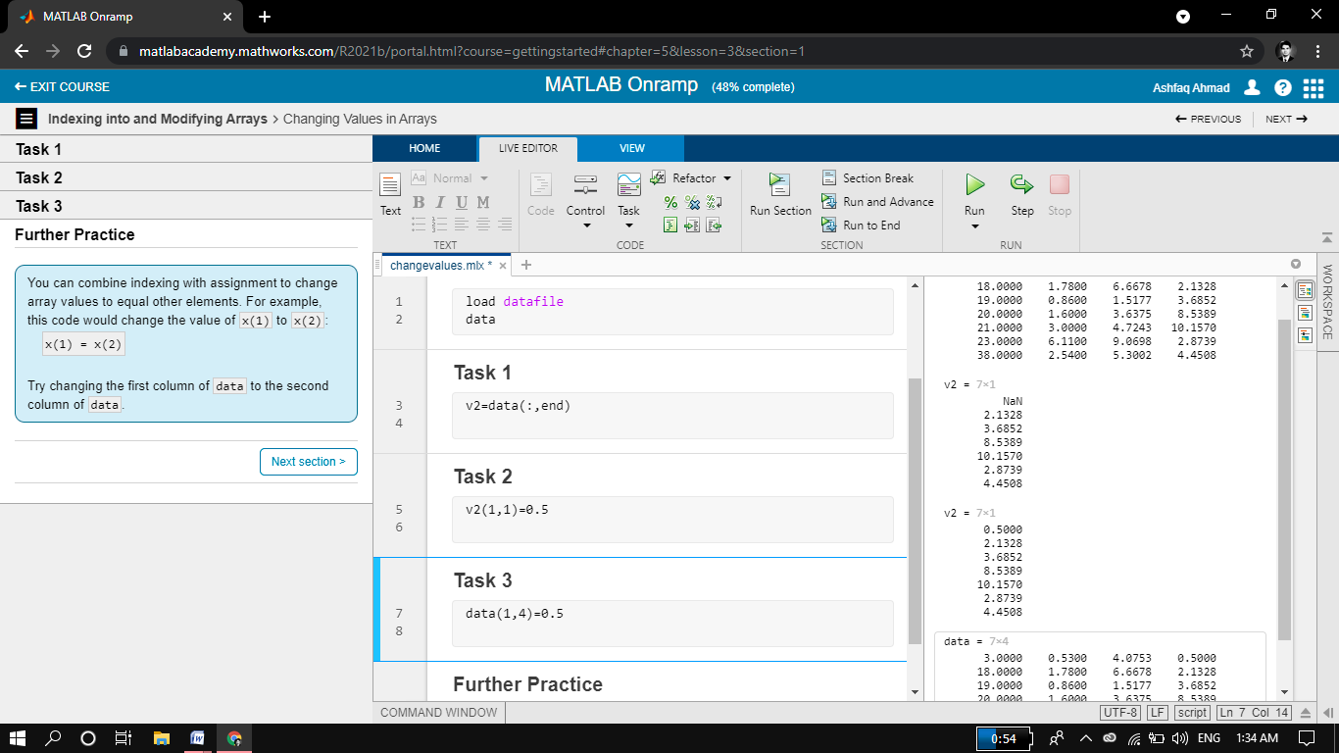

Remarks:

* We can do different operation with matrix.
* We can access each element of matrix also we can modify it.

### Array Calculations

### Objective: Perform calculations on entire arrays at once.

* 1. Remarks along with final snapshot.

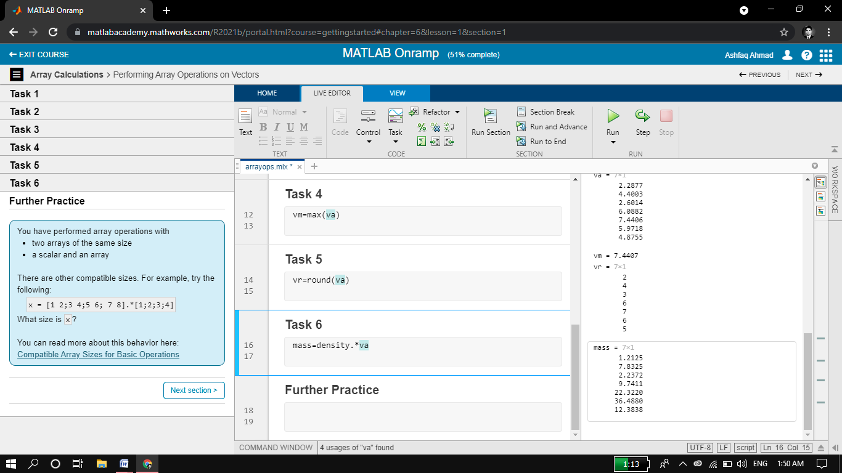

Remarks:

* We can do different operation with array.
* We can add two matrixs subtract, divide and multiply element by element.
* We can also multiply, add, subtract and divide a matrix by a real no.

### Calling Functions

### Objective: Call functions to obtain multiple outputs

* 1. Remarks along with final snapshot

### 

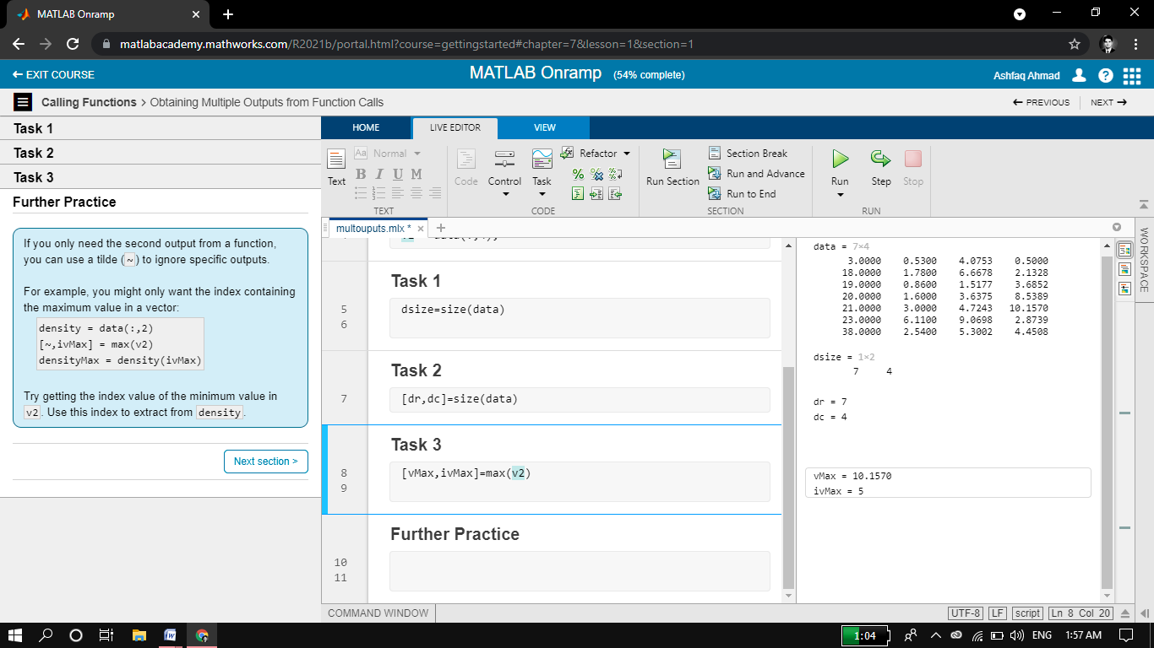

Remarks:

* Call function is used for multiple output like size, mini etc.
* We can ignore specific output using (~).
* Clc , clear, close all are also call function.

### Obtaining Help

### Objective: Use the MATLAB documentation to discover information about MATLAB features.

* 1. Remarks along with final snapshot

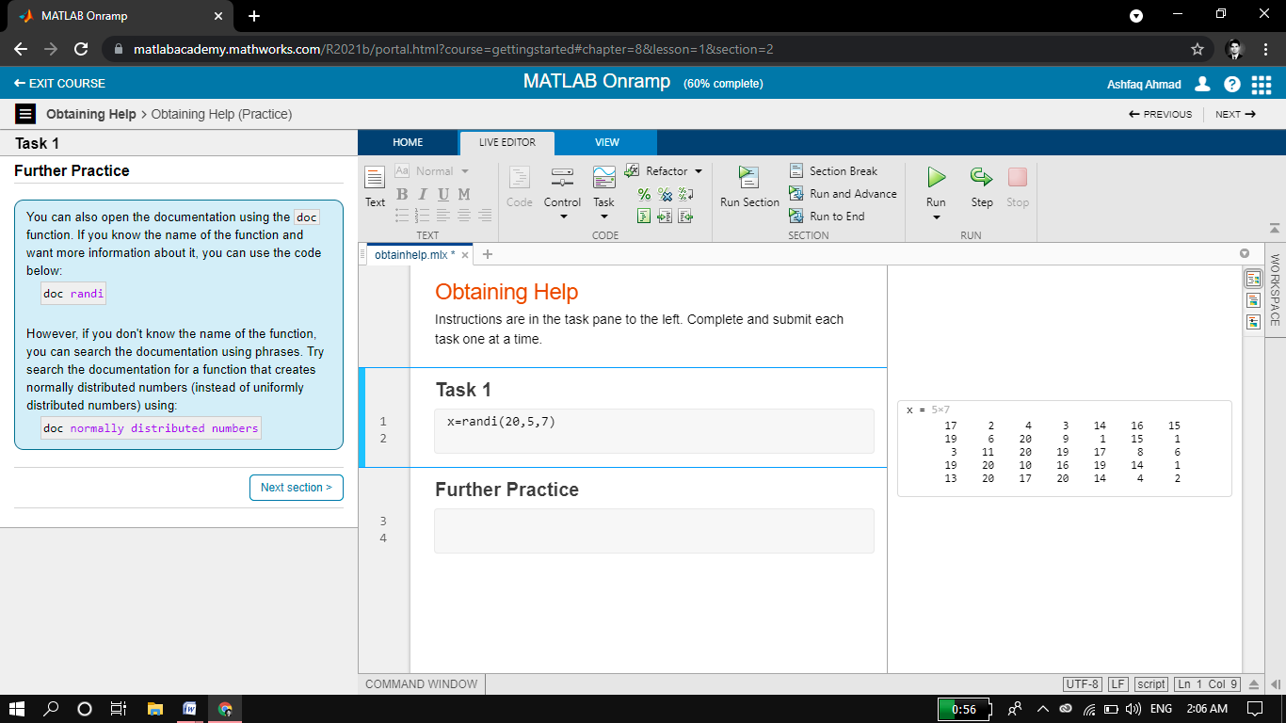

Remark:

* We can get help about any command from matlab documentation.
* “Help command _name”.

### Plotting Data

### Visualize variables using MATLAB's plotting functions.

* 1. Remarks along with final snapshot

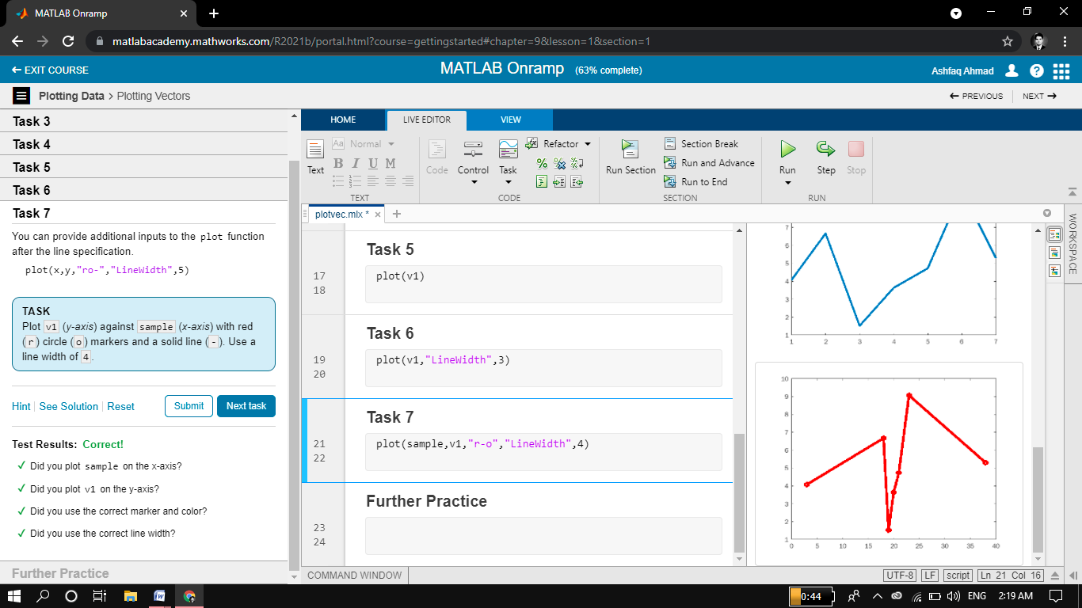

Remark:

* We can plot array or vector data graphically both in continus and discrete form.
* For discrete we use stem and for continus plot is used.
* We can label any string on x-axis and y-axis using xlabel and ylabel.

### *Review Problems*

### Objective: Bring together concepts that you have learned with a project.

* 1. Remarks along with final snapshot

Remarks:

* After we create an optimization problem, we can review its formulation by using show. For large problems, use show instead. For example,

prob = optimproblem;

x = optimvar('x',2,'LowerBound',0);

prob.Objective = x(1) - 2*x(2);

prob.Constraints.cons1 = x(1) + 2*x(2) <= 4;

prob.Constraints.cons2 = -x(1) + x(2) <= 1;

show(prob)

### MATLAB Scripts

### Objective: Write and save your own MATLAB programs

* 1. Remarks along with final snapshot

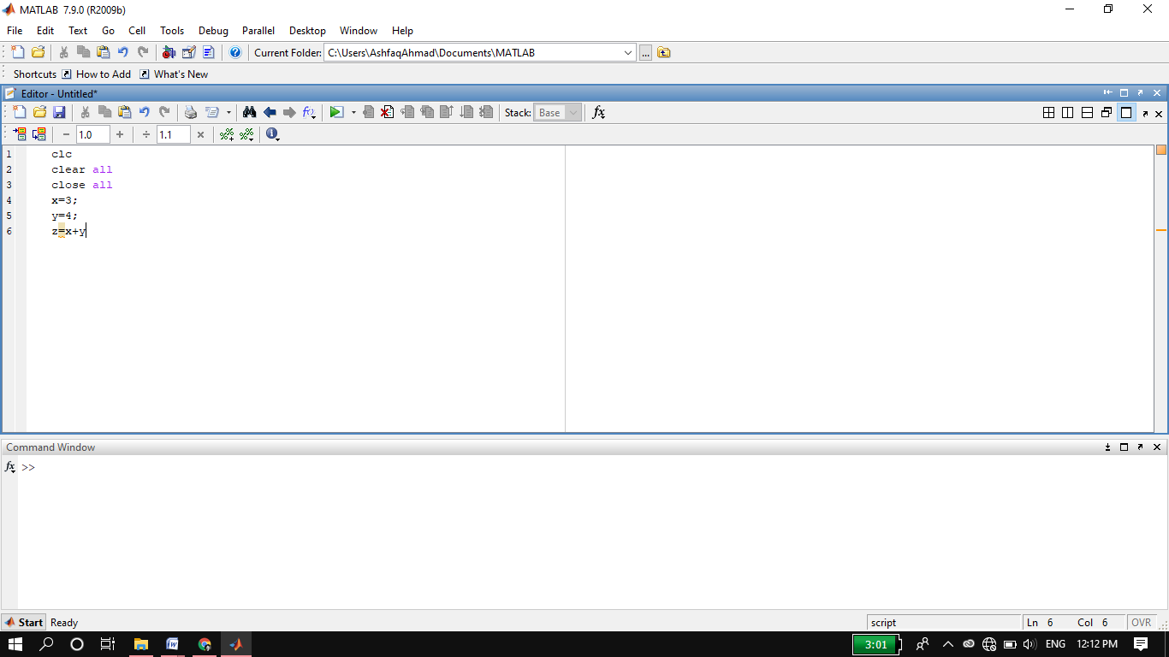

**Remarks:**

* A matlab script is a window of matlab in which we write program itself.
* A matlab script program is run in command window.
* We can edit matlab script program.
* Also we can save matlab script program.

### Logical Arrays

### Objective: Use logical expressions to help you to extract elements of interest from MATLAB arrays.

* 1. Remarks along with final snapshot.

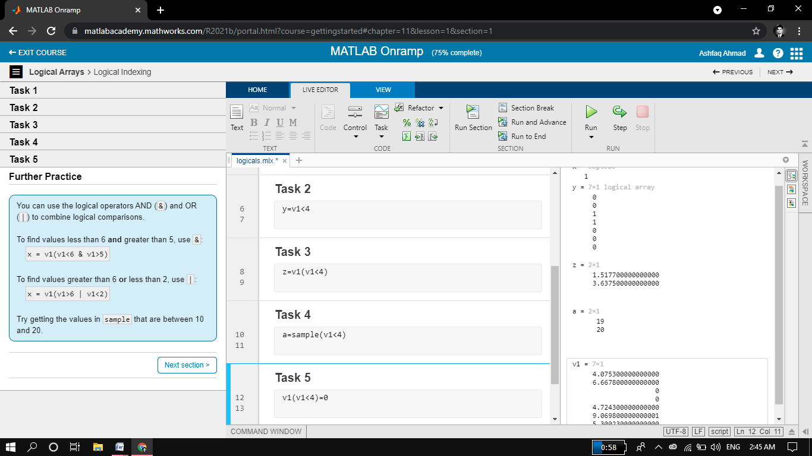

Remark:

* We use conditional operator for any specific condition such as greater than, less than or equal to.

### Use logical expressions use to help us to extract elements of interest from MATLAB arrays.

### Programming

### Objective: Write programs that execute code based upon some condition.

* 1. Remarks along with final snapshot

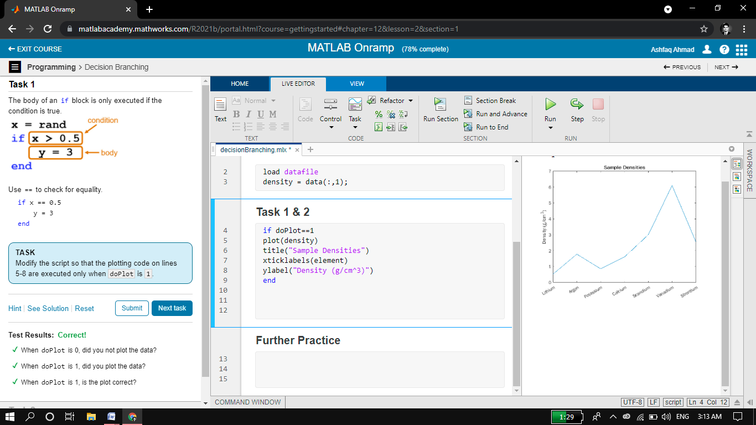

Remark:

* Programming means writing code in a script.
* Here we used some conditional statements and then plot the data.

### Final Project

### Objective: Bring together concepts that you have learned with a project.

* 1. Remarks along with final snapshot

**Project 1:**

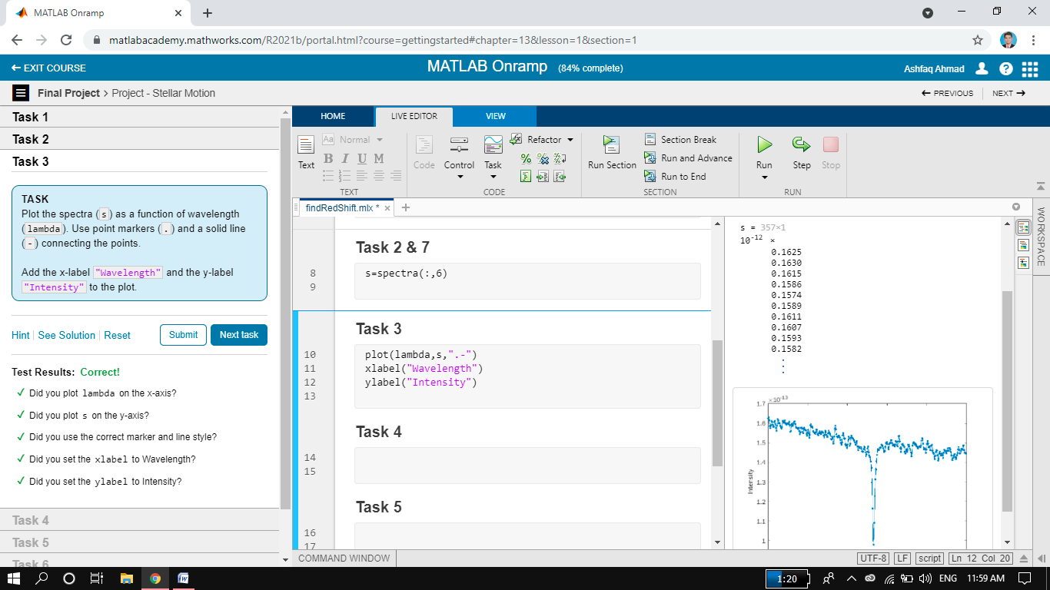

**Project 2:**

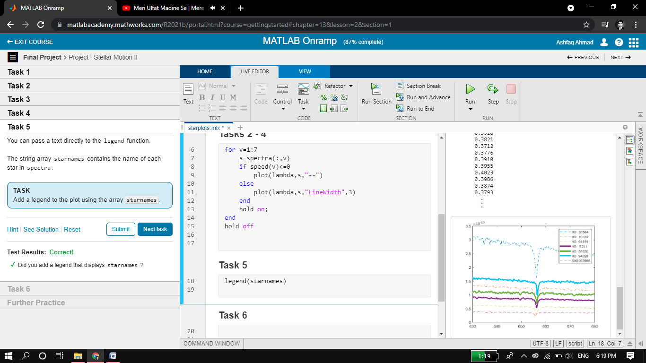

Remarks:

* Here we use all concepts studied in this course and performed the final project which is about plotting.

1. **Math Works Certificate**

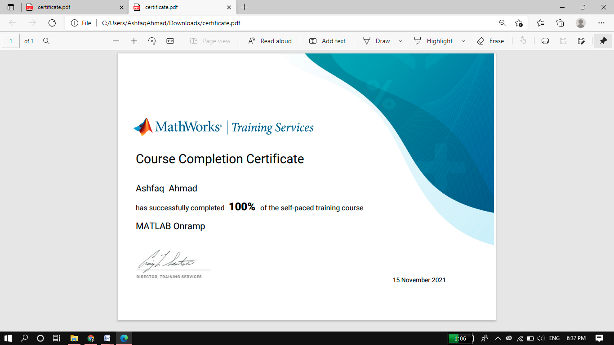

#### 

#### The End